Exercise 2: Implementing Dependency Injection
Scenario:
In the library management application, you need to manage the dependencies between the BookService and BookRepository classes using Spring's IoC and DI.
1. Modify the XML Configuration:
o Update applicationContext.xml to wire BookRepository into BookService.
applicationContext.xml:
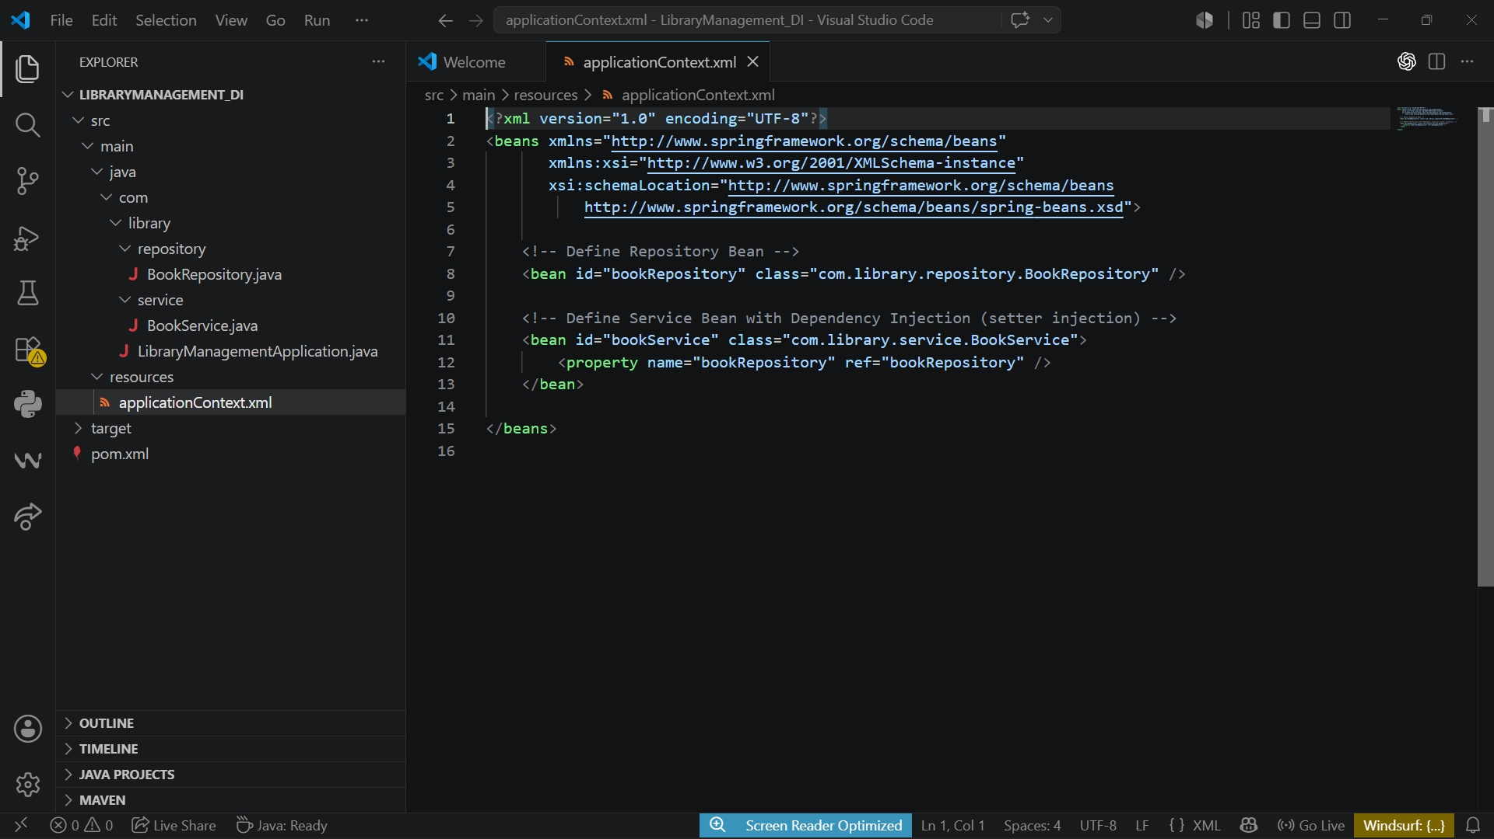

2. Update the BookService Class:
o Ensure that BookService class has a setter method for BookRepository.
BookService.java
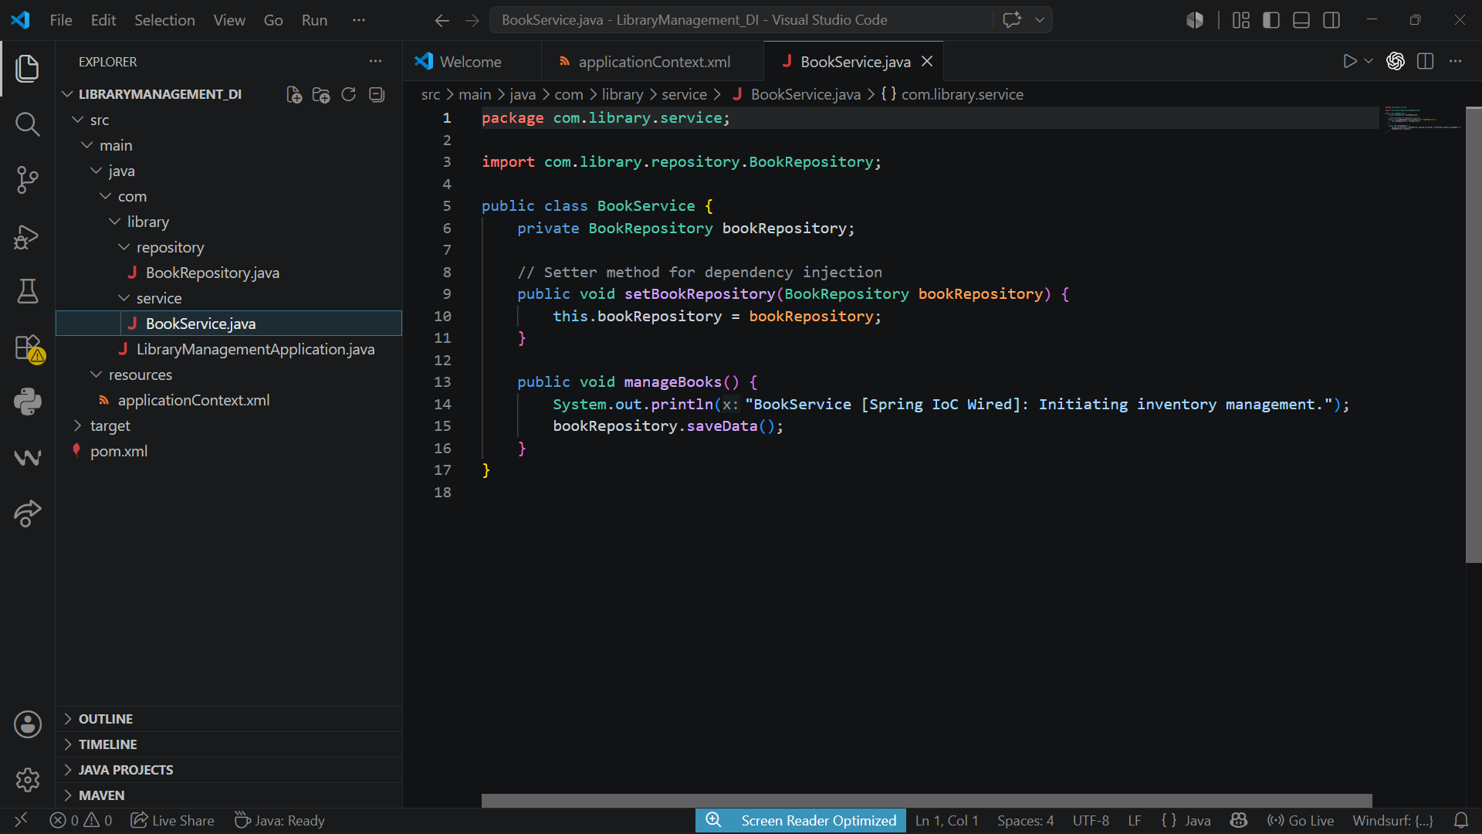
BookRepository.java:
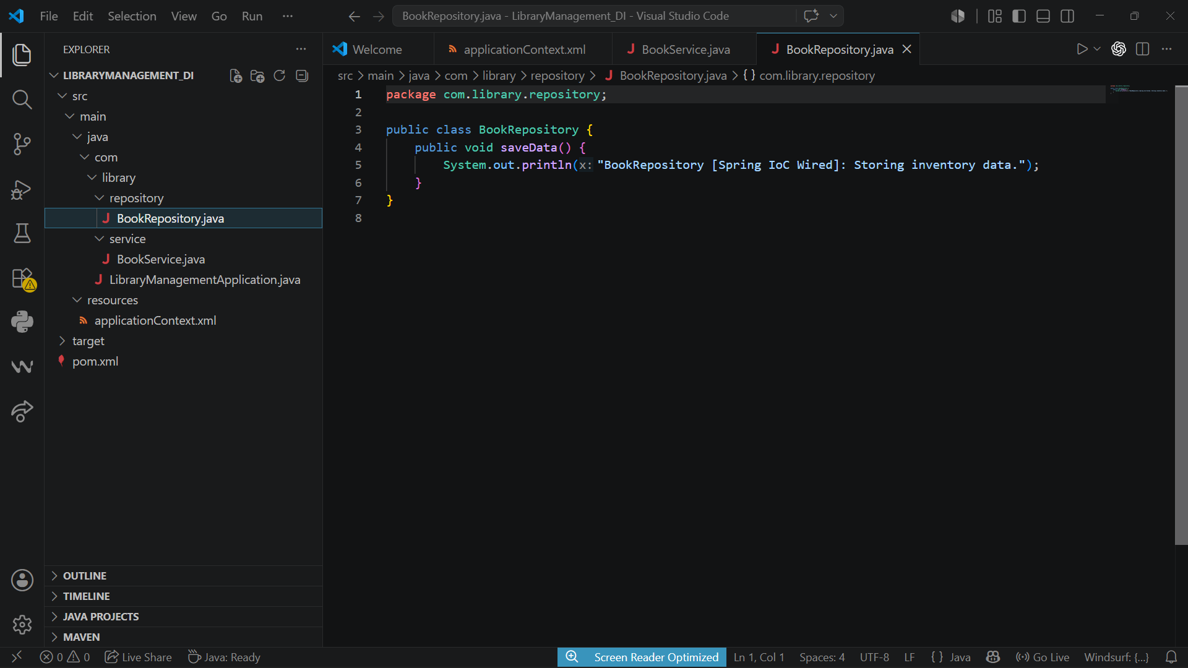

3. Test the Configuration:
o Run the LibraryManagementApplication main class to verify the dependency injection.
Output:
